

***HTML Essentials***

**Lab Guides**

|  |  |
| --- | --- |
| Document Code | 25e-BM/HR/HDCV/FSOFT |
| Version | 1.1 |
| Effective Date | 20/11/2012 |

**Hanoi, 04/2019**

RECORD OF CHANGES

|  |  |  |  |  |  |
| --- | --- | --- | --- | --- | --- |
| No | Effective Date | Change Description | Reason | Reviewer | Approver |
|  | 25/Jun/2018 | Create a new Lab | Create new | DieuNT1 | VinhNV |
|  | 01/May/2019 | Update Fsoft Template | Update | DieuNT1 | VinhNV |
|  |  |  |  |  |  |
|  |  |  |  |  |  |
|  |  |  |  |  |  |
|  |  |  |  |  |  |
|  |  |  |  |  |  |
|  |  |  |  |  |  |
|  |  |  |  |  |  |
|  |  |  |  |  |  |

Contents

Unit 4 – Hyperlinks 4

Lab Objectives: 4

Problem Descriptions: 4

Guidelines: 5

Step 1: Analyze Requirements 5

Step 2: Build the structure 5

Step 3: Add more details 5

Step 4: Code HTML 6

Step 5: Verify Output 6

|  |  |
| --- | --- |
|  | **CODE: HTML-E.S.L401**  **TYPE: Short**  **LOC: N/A**  **DURATION: 30 MINUTES** |

# Unit 5 – Multimedia

## Lab Objectives:

* Able to use Multimedia tag to display audio, video

## Problem Descriptions:

In this problem, we going to build a News app which will display News in multiple format such as audio, video. The app looks like figure below:

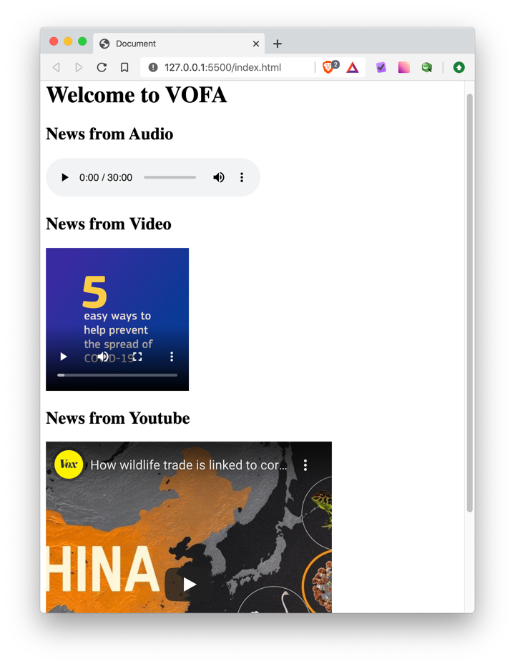

## Guidelines:

Step 1: Analyze Requirements

Firstly, we must analyze the output and identify as much elements as possible. By going from top to bottom, we check each block and have the result below:

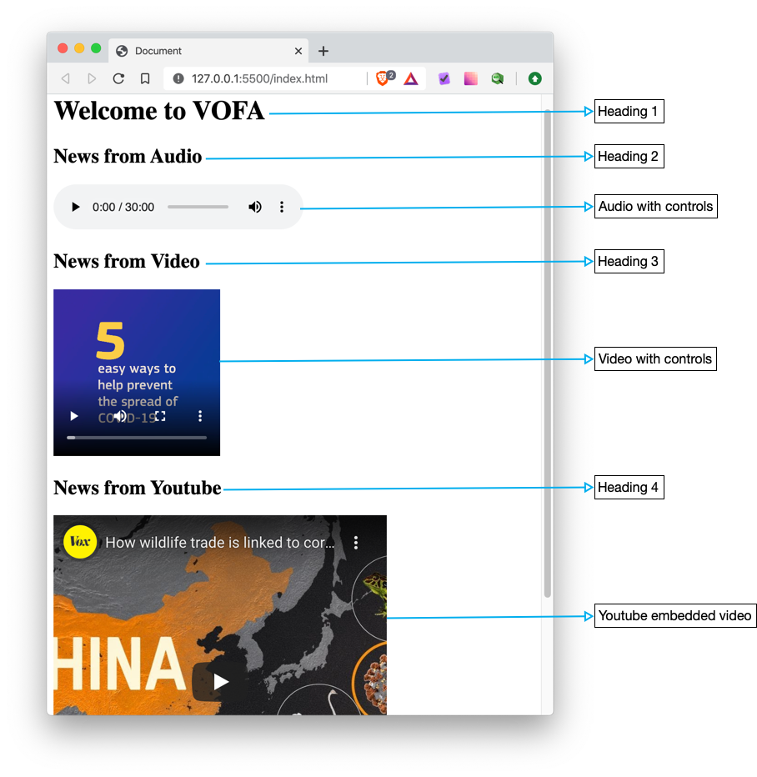

Step 2: Build the structure

Next, we will transform each element identified above to HTML elements.

* Heading 1 will be <h1>…</h1>
* Heading 2 will be <h2> (or <h3> but never be <h1>)
* Audio with controls will be: <audio controls></audio>
* Heading 3 is the same as Heading 2 (but different content)
* Video with controls will be: <video controls><source></video>
* Heading 4 is the same as Heading 2
* Last item is an embedded Youtube video: <iframe src=”https://youtube.com/embeded/”>

Step 3: Add more details

After come up with the HTML elements, we must fill now the content and details else we can’t see anything

Heading 1 is simply:

1. <h1>Welcome to VOFA</h1>

Heading 2 is:

1. <h2>News from Audio</h2>

For the audio, we just give a relative URL path to **src** attribute:

1. <audio src="audio.mp3" controls></audio>

Heading 3 is:

1. <h2>News from Video</h2>

Then come the video (notice the <source> tag inside, as we might want to add more video format to support older browsers)

1. <video controls width="200" height="200">
2. <source src="video.mp4" />
3. </video>

Heading 4 is trivial:

1. <h2>News from Youtube</h2>

Lastly, we add an <iframe> to embed Youtube video. **Note:** only src attribute is required all other attributes are optional.

1. <iframe
2. width="400"
3. height="400"
4. src="https://www.youtube.com/embed/TPpoJGYlW54"
5. frameborder="0"
6. allow="accelerometer; autoplay; encrypted-media; gyroscope; picture-in-picture"
7. allowfullscreen
8. ></iframe>

Step 4: Code HTML

Finally, we put every piece together and come up with fully working code.

1. <!DOCTYPE html>
2. <html lang="en">
3. <head>
4. <meta charset="UTF-8" />
5. <meta name="viewport" content="width=device-width, initial-scale=1.0" />
6. <title>Document</title>
7. </head>
8. <body>
9. <h1>Welcome to VOFA</h1>
10. <h2>News from Audio</h2>
11. <audio src="audio.mp3" controls></audio>
12. <h2>News from Video</h2>
13. <video controls width="200" height="200">
14. <source src="video.mp4" />
15. </video>
16. <h2>News from Youtube</h2>
17. <iframe
18. width="400"
19. height="400"
20. src="https://www.youtube.com/embed/TPpoJGYlW54"
21. frameborder="0"
22. allow="accelerometer; autoplay; encrypted-media; gyroscope; picture-in-picture"
23. allowfullscreen
24. ></iframe>
25. </body>
26. </html>

Step 5: Verify Output

* Save the HTML code from Step 4 into **index.html** file
* Open it with Live Server and verify the output

**-- THE END --**